# API Landscape

Step:1:- database tables

. travelontip

.fastgo

**Fastgo external api:**

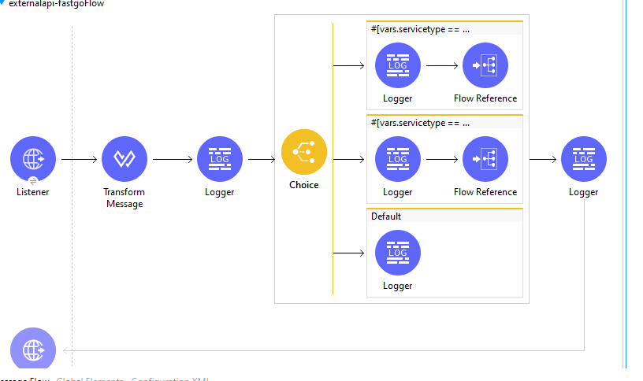

The flow represents the process of external api fastgo:

1.In transform message we pass a variable =service type

2.And in choice we give conditions like routs,schedules and default conditions.

3.when we give service type = routes, then the first condition in choice will execute.

4.when we give service type=schedules,then the second condition in choice will execute.

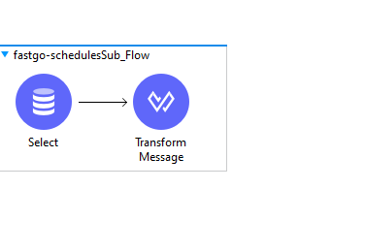

By flow reference we add a sub-flow for routes and schedules.

In select we write a query for retrieving data from database. And in payload we get the details of the selected query.

**Externalapi for travelontip**

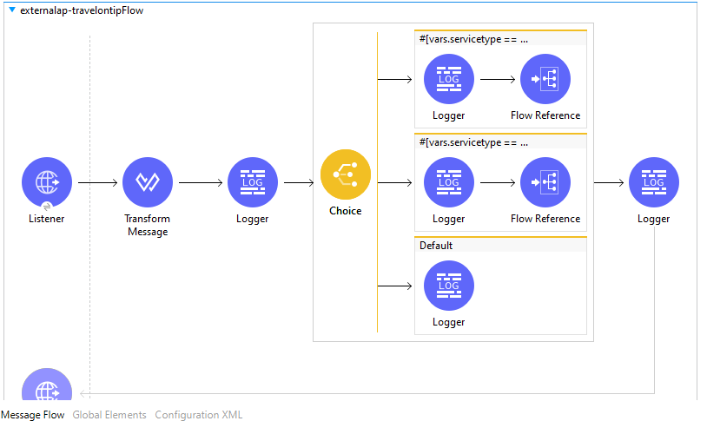

Same as above flow,we implemented for travelontip.

**Systemapi-fastgo**

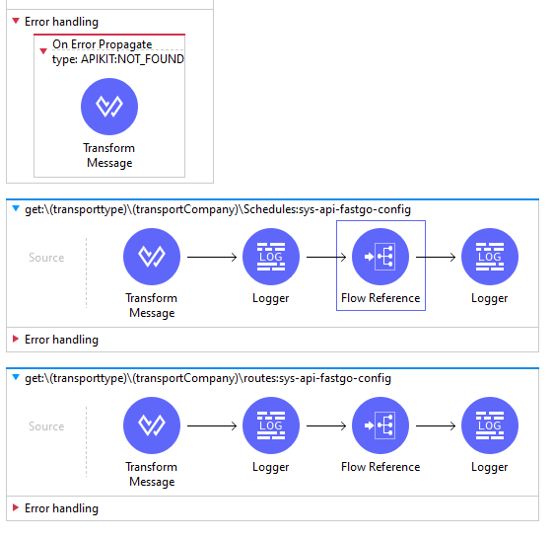

Imported raml file from any point studio and in transform message = transactionId and in flow reference we connect the sub flow.

In sub flow we invoke the url of external layer for fastgo

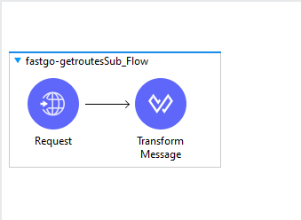

Sub flow for schedules

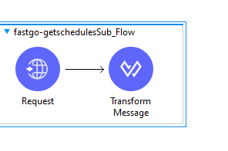

**System api for travelontip:**

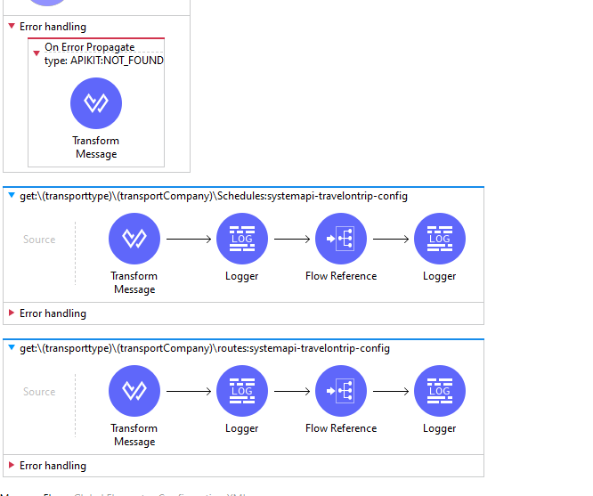

**Import raml file from any point platform**

**In transform message we set a variable = transactionId and in flow reference of schedules we created in sub flow**

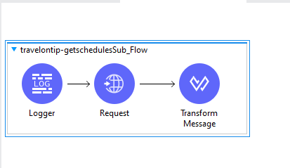

**In Request we pass the url of external api of fastgo and in transform message the required payload.**

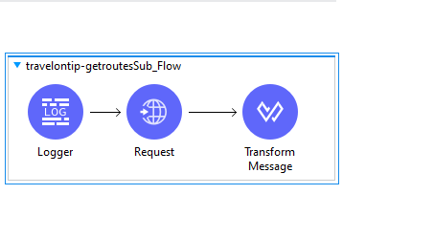

**Request component for routes.**

**Process api for travelontip and fastgo**

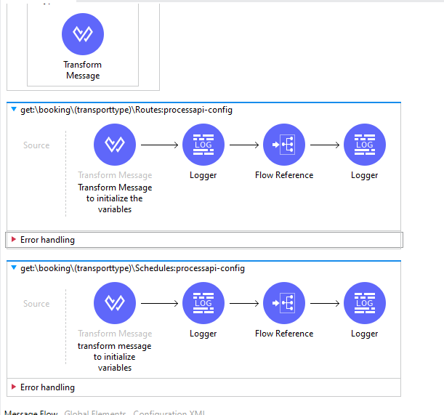

**In transform message is set a variable = destinationLocation.And in flow reference we connect with sub flow of routes.**

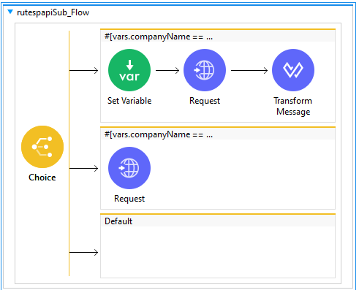

**In choice condition for first flow (If company name=fastgo)**

**We pass the systemapi of fastgo url in request component**

**If company name = travelontip the second flow will be executed.**

**And in request component we pass the url of travelontip systemapi.**